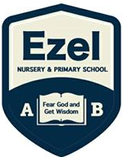 | EZEL NURSERY AND PRIMARY SCHOOL  Home Learning Program  www.ezelschool.com/homelearning.html
BABY CLASS

Week 1
MONDAY
 | Topics | Activities
Math | - Counting Numbers  - Writing Numbers | - Count numbers from 1 to 5  - Trace number 1
English | - Speaking English | - New Word: house  - Read the word house  - Draw a house
Literacy | - Practice letter sounds | - Read the letter a and b  - Say the sounds of letter a and b  - Say words that begin with letter a and b
Sight words |  | on , in
TUESDAY
 | Topics | Activities
Math | - Counting Numbers  - Writing number | - Counting Numbers from 1 to 5  - Trace number 1 and 2  - Coloring number 1 and 2
English | Practice speaking English | Recite the following (5 times).  - Today is Tuesday  - I can read and write.
Literacy | Practicing letter sounds | New words: axe , boy  - Read letters a , b and c  - Say the sounds of letter a , b and c  - Say words that begin with letter a, b and c.  Examples: ant, ball, arrow , bat
Sight words |  | on , in (explain to the child the meaning of the words)
WEDNESDAY
 | Topics | Activities
Math | - Counting Numbers  - Writing numbers | - Counting numbers from 1 – 5  - Trace number 1, 2 and 3  - Color number 1 , 2 and 3
English | Practice speaking English | - New word: cup  - Read the word tree  Activity: Draw a cup  Recite the following (5 Times):  - My cup is on the box.
Literacy | Practicing letter sounds | Vocabulary (new words): box , cup  - Read the letter b and c  - Say the sounds of letter a , b and c  - Say words that begin with a , b and c
Sight words |  | on , in , my
THURSDAY
 | Topics | Activities
Math | Counting number  Writing numbers | Fill in the missing numbers.  1 , _____, 3 , _______, 5
English | Practice speaking English | Activity: Recite the following.  - Today is Thursday.  - My name is good.  Note: explain to the child the meaning of the words.
Literacy | Practice letter sounds | Vocabulary (new words): book, coat  - Read letters a , b , c  - Say the sounds of letter a , b and c  - Say words that begin with letter a , b and c
Sight words |  | my, on , in , is
FRIDAY
 | Topics | Activities
Math | - Count numbers  - Write numbers | Fill in the numbers that come before and after.  - ____, 3 , ________  - _____ , 4 , ________
English | Practice speaking English | Vocabulary : cow  Activity:  - Read the vocabulary word.  - Draw a cow
Literacy | Practice letter sounds | Vocabulary: axe, ant, boy, ball, bat, cat , cow, cup  Activity  - Read letter a, b and c  - Say the sounds of letter a , b , C  - Say words that begin with the letters a , b, c
Sight words |  | My , on , in , is

Note: Dear parents/caregivers always make sure that
- You explain new words to your child.
- Recite new words as many times as you can
- Be kind and patient with your child, they cannot learn new things in one day.
- Provide your child with books, pencils, crayons and papers.

ACTIVITIES
Activity 1: Tracing number 1 – 2
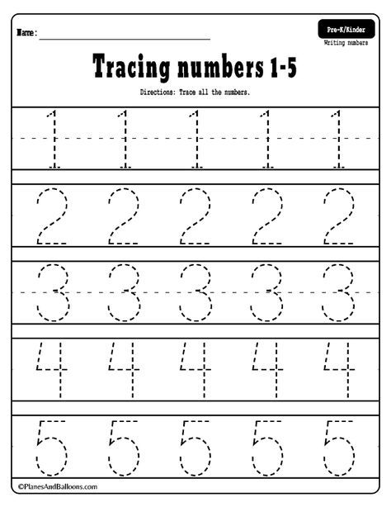

Activity 2 :Colour the letters and number below
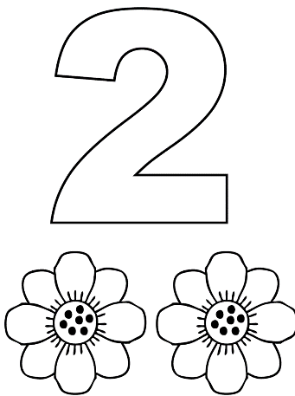

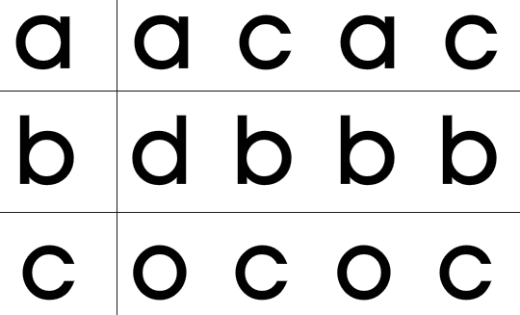  Activity 3: Circle letters that matches the first letter in every row. | Activity 4: Trace and Count  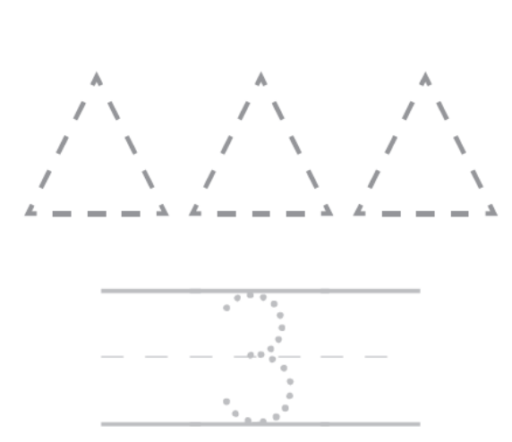
Activity 5: Match correctly
1 | 2 | 3 | 4 | 5

Activity 6: Letter A
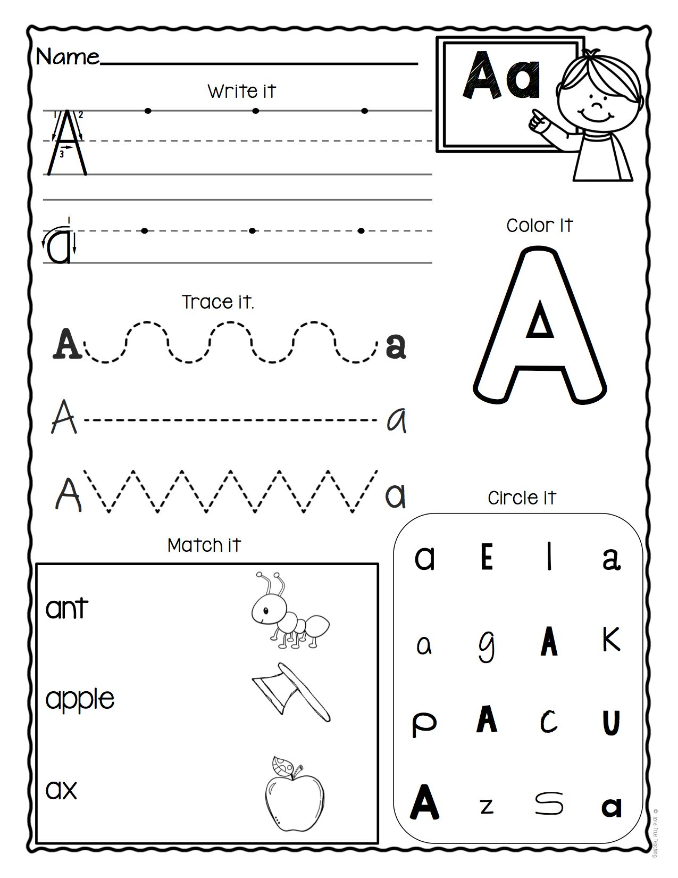
For more information, call:
Agule area and all other areas | Kameke Area
0772644523 | 0758650099 | 077074014 | 0786560989 [Director God Help Junior School]

